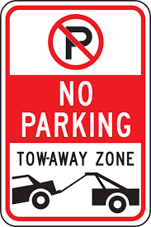**NO PARKING VIOLATION**

3035,Delhi,India| 222 555 7777

Fax:123-123-123456

**PAYMENT RECEIPT**

**Date:{receipt_date}**

**Receipt No.:** {receipt_no}

**BILLED TO**

**Client Name:** {name}

**Address:** {address}  
 **Phone:** {phone_no}

**Memo Date:** {memo_date}

|  |  |  |
| --- | --- | --- |
|  |  | **Amount** |
| **Parking Violation** |  | **470.77 Rs.** |
|  |  |  |
| **Subtotal 470.77 Rs.** | | |
| Gov Tax (7%) |  | 29.23 Rs. |
| **Total Amount** |  | **500.00 Rs.** |

**PAYMENT DETAILS**

**Payment Date :**  {paydate}

**Payment Method:**  Online

**Amount Paid :** 500.00 Rs.

**Transaction No :** {tno}.